SWE209 Object Oriented Analysis and Design Homework 2

NAME : HAYRUN NİSA ÇELİK

STUDENT NO : B211202009

**ELİTES’ SYSTEM**

**(ES)**

1. **Introduction**
   1. Purpose: The purpose of developing the University's information system called ELITES’ SYSTEM (ES) is to make easy some functions for user .The main of these functions are enrolling course, tracking internships and other announcements, grading students’ notes etc. The goal of the system is to eliminate the existing mistakes and inefficiencies found in both manual and automated procedures while providing a user-friendly interface.
   2. **Scope :** The ES; It includes everyone affiliated with the institution, such as students, faculty members, administrative staff, university administrators. The ES makes it easier for students to access course details, register and review academic records. It also supports faculty members with tasks such as grading, homework management, and supervising course-related tasks.
   3. **Objectives**

* The ES notifies students of required failed courses upon selecting new courses.
* The ES ensures that it accurately calculates student averages based on recorded grades.
* Tracking and managing students’ internship requests within the system.
* The ES ensures accurate recording of degrees for students enrolling in the University.
* The ES is accessible to all users every hour of the day.
* The ES maintains a user error rate below 10% for payment details submission at the checkout page.
* The ES provides information on passing scores for courses and inform students of required scores to pass.

1. **Current system** :The system that The University of Elites uses for most transactions is generally based on automatic transactions. But the software is so bad that it often gives errors or allows incorrect data entry while most of the transactions. So, the faculty members have to use manual transactions too.
2. **Proposed System**
   1. **Overview :** The primary objective of the system is to streamline multiple operations like enrollment, course administration, and monitoring grades. Its aim is to offer a user-friendly interface for precise and efficient management of student information. This system will grant students, faculty, and administrative staff access to vital functions, such as simplified course enrollment, convenient retrieval of academic records, prompt communication, and extensive reporting tools. Essentially, its core focus lies in rectifying current process errors and inefficiencies while introducing novel features that enrich user experience and foster seamless interactions among the university community.
   2. **Functional Requirements**
      * 1. ES should allow students choose the courses they must take and with each course selection, ES should notify students that they must register for the courses they failed**.**
        2. The teachers can record students’ grades and ES and ES ensures that students' averages are accurately calculated.
        3. ES tracks the students’ internship requests
        4. ES ensures that the students who wants to enroll at the University, be recorded correct degrees.
        5. The rector can assign various duties on deans of faculties via ES.
        6. Teachers can give assignments to students. Students can upload these assignment to ES. Teachers control students’ assignments via ES.
        7. If there are activities that organized by students’ faculties , ES will inform students via email.
        8. In courses where attendance is important, ES records the student's attendance and calculates how many more days he/she can be absent.
        9. ES allows students to log in their account via the password they choose but if they forget their passwords, ES send a link to renew their passwords.
        10. ES have passing scores information for every courses and if user wants, the system will inform student how much score should he/she must get to pass the course.
        11. There can be online exams and the system should be arrange and allow users do their exams without an error.
   3. **Nonfunctional Requirements**
      * 1. The ES should have a button which shows student’ informations, photos and mails on the website. (Interface)
        2. The ES supporting a lot of students per hour must provide 6 second or less response time in a browser. (Performance)
        3. The ES must support at least 20.000 students’ transactions at the same time and it should protect its performance quality also. (Scalability)
        4. The ES should be available for all users every hour during the day.(Availability)
        5. The error rate of faculty members submitting their students’ grades details at the checkout page must not exceed 10 percent. (Reliability)
   4. **System Model**
      1. **Scenarios**
         1. **SCENARİO 1**

|  |  |
| --- | --- |
| **Scenario name** | CourseEnrollment |
| **Participating actor instances:** | Kübra: Administirator Burak: Faculty Member Sevgi: student Ali: Rector |
| **Flow of events** | 1. Kübra, a dean, logs into the university management system to oversee the enrollment process for the upcoming semester. 2. Burak, a faculty member, logs in to the system to update the list of available courses and their prerequisites for the next semester. 3. Sevgi, a student, logs into the system to view the available courses. She selects her desired courses for the semester. 4. The system warns te Sevgi to enroll the course if she failed this couse. 5. Sevgi sends the complete selection of the courses to Burak. 6. When Burak receives the selection, He approves and the course enrollment will be completed. |

**3.4.2 Use case model**

|  |  |
| --- | --- |
| **USE CASE NAME** | **Recordandcalculategrades** |
| **PARTICIPATING ACTOR** | **FACULTY MEMBER** |
| **FLOW OF EVENT** | **1.** The faculty member logs in to their account in the system using a password.  **2**. In response, the ES immediately presents faculty member with an interface of things the user can do in the account.  **3.** The faculty memberselects the grading button and record grades for every students  4. The ES uses the grades and calculates grades students need to pass.  5. The faculty member log out to their account. |
| **Entry condition** | The user log in to their account. |
| **Exit condition** | The user log out their account. |
| **Quality requirement** | The error rate of faculty members submitting their students’ grades details at the checkout page must not exceed 10 percent. |

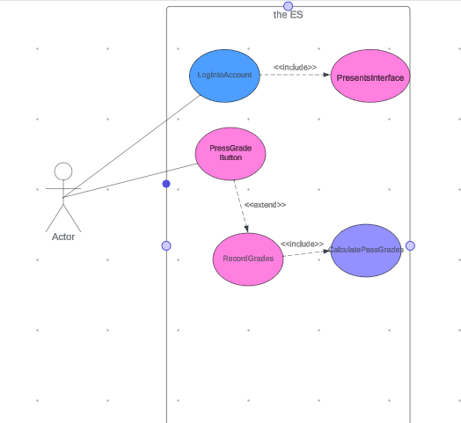

**RecordandCalculate USE CASE diagram**

|  |  |
| --- | --- |
|  |  |

|  |  |
| --- | --- |
| **USE CASE NAME** | **Assignmentmanagement** |
| **PARTICIPATING ACTOR** | Initiated by faculty member  Communicates with student |
| **Flow of events** | **1.** The faculty member accesses the system to create a new assignment.  **2.** The ES notifies the Students about the newly created assignment.  **3.** Thestudent select the assignment to work on and review its details.  **4.** After completing the assignment, Student uploads his/her work via the system, attaching any required files.  **5.** The ES confirms successful submission and timestamps the submission.  **6.** Teachers evaluate and grade the submissions, providing feedback if necessary.  **7.** The ES notifies Students about graded assignments and displaying their scores. |
| **Entry condition** | The faculty member logs in and accesses to the ES |
| **Exit condition** | IfStudents have received notification of their grades for the specific assignment. |
| **Quality requirement** | The ES must support all of the students’ assignments upload transaction at the same time. |

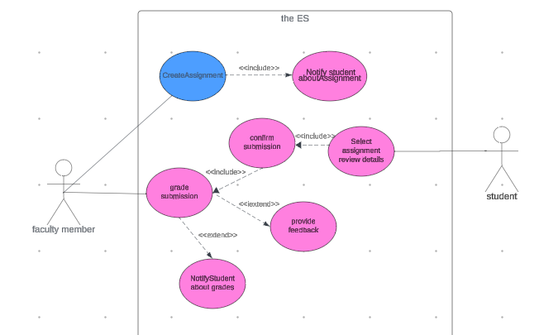

**AssignmentManagement use case diagram**

|  |  |
| --- | --- |
| **USE CASE NAME** | **Intershipsrequest** |
| **PARTICIPATING ACTOR** | **Initiated by student** |
| **FLOW OF EVENTS** | **1.** The student accesses the system and submits an internship request, providing details such as preferred companies, internship duration, and area of interest.  **2.** If matching opportunities are available within the ES's database or from partnered organizations, the ES notifies the student about potential internship openings.  **3.** Upon receiving notification of an available internship, the student reviews the details and decides to accept the offer or not.  **4.** The ES confirms the acceptance and provides detailed information about the internship, including company details, start date, responsibilities, and any necessary documentation. If the student does not want to accept the offer, The ES will offer other internship options. |
| **Entry condition** | The Students logs in and accesses to the ES |
| **Exit condition** | * The ES confirms the acceptance and provides detailed information about the internship. OR * If the student does not want to accept the offer, The ES will offer other internship options |
| **Quality requirement** | Once the internship announcement arrives in the system's database, ES must inform the user within 1 minute. |

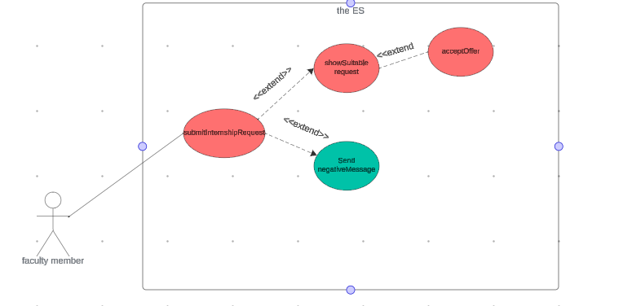

**InternshipRequest use case diagram**

1. **Glossary:**

ES : Elites’ System

Rector : The head of the University

Dean: The head of the faculty

User : the person who use the system

Faculty member : the person who works in the faculty

Internship : the position of a student or trainee who works in an organization, sometimes without pay, in order to gain work experience or satisfy requirements for a qualification.